Plastic_Fish
Plastic_Car
Plastic_Waste
Wooden_Block
Wooden_Bangle
Green_Leaf
Sea_Shell
Metal_Key

metal_screw

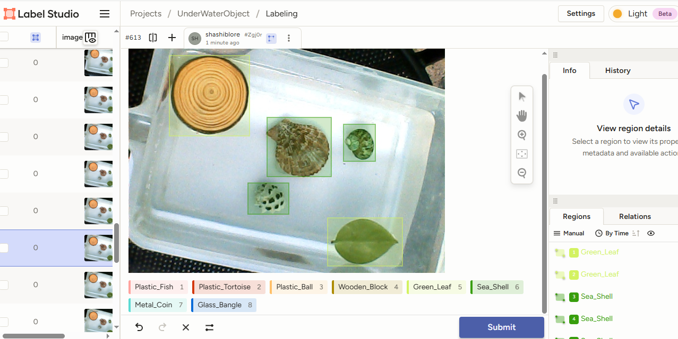

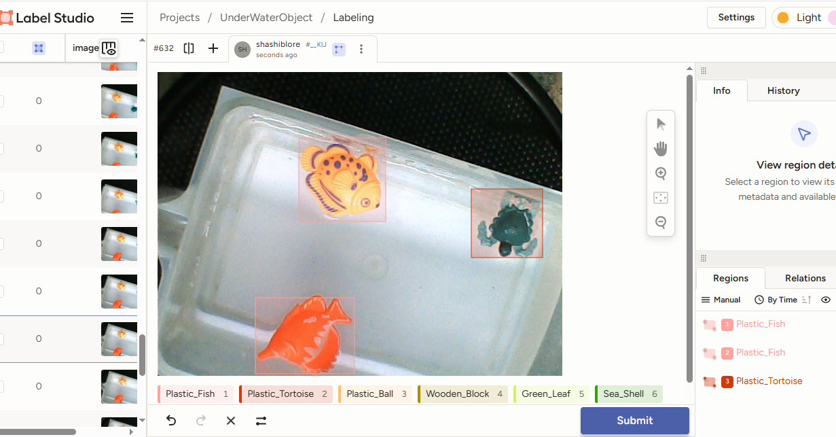
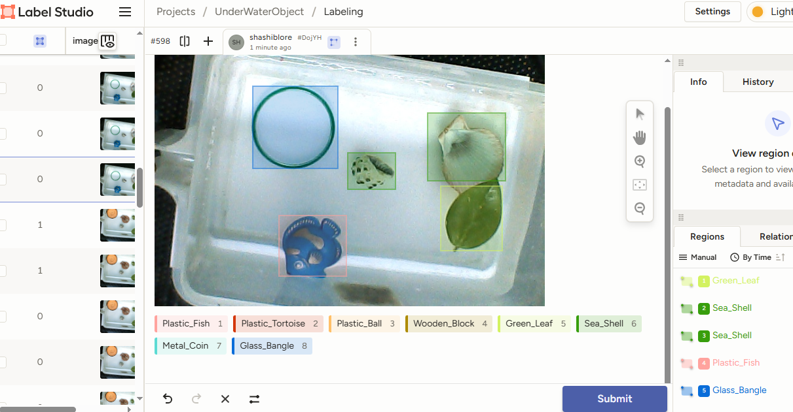

Yolo11CustomImgModelTrain.ipynb
In google colab, run code to train our custom images using yolo11n.pt (n – nano, suited for PI4). Upload our images zip/rar folder in google drive.
Run code Install ultralytics, mount google drive, extract YoloImg9TrainVal.rar to datasets folder

!unrar x "/content/gdrive/MyDrive/WatObjYoloImg8TrainVal.rar" "/{HOME}/datasets/"

Create a new file data.yaml in this path /content/datasets/YoloImg9TrainVal/data.yaml. Save below code in data.yaml file. Do respective changes as per the project.

train: ../WatObjYoloImg8TrainVal/train/images
val: ../WatObjYoloImg8TrainVal/train/images
#number of classes
nc: 8
#class names
names: ['Glass_Bangle','Green_Leaf','Metal_Coin','Plastic_Ball','Plastic_Fish','Plastic_Tortoise','Sea_Shell','Wooden_Block']

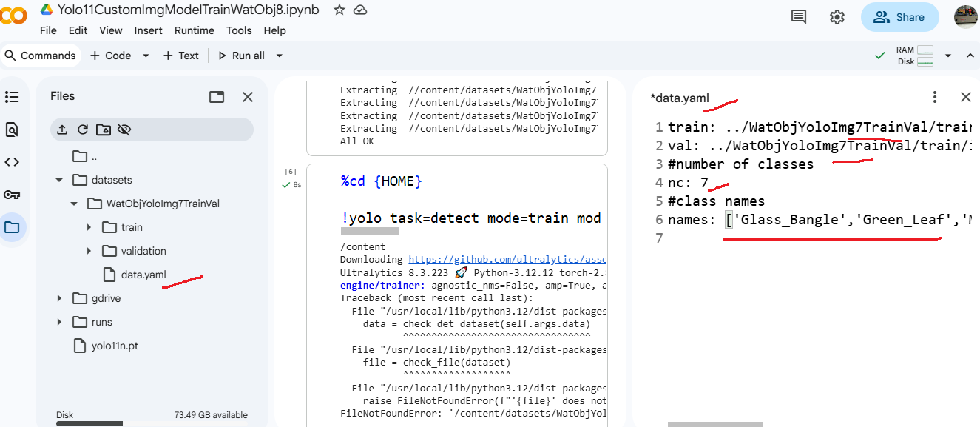

Run model train code
!yolo task=detect mode=train model=yolo11n.pt data=/content/datasets/ WatObjYoloImg8TrainVal/data.yaml epochs=20 imgsz=240 plots=True

After training completed, download, best.pt file in path runs/detect/train2/weights/best.pt

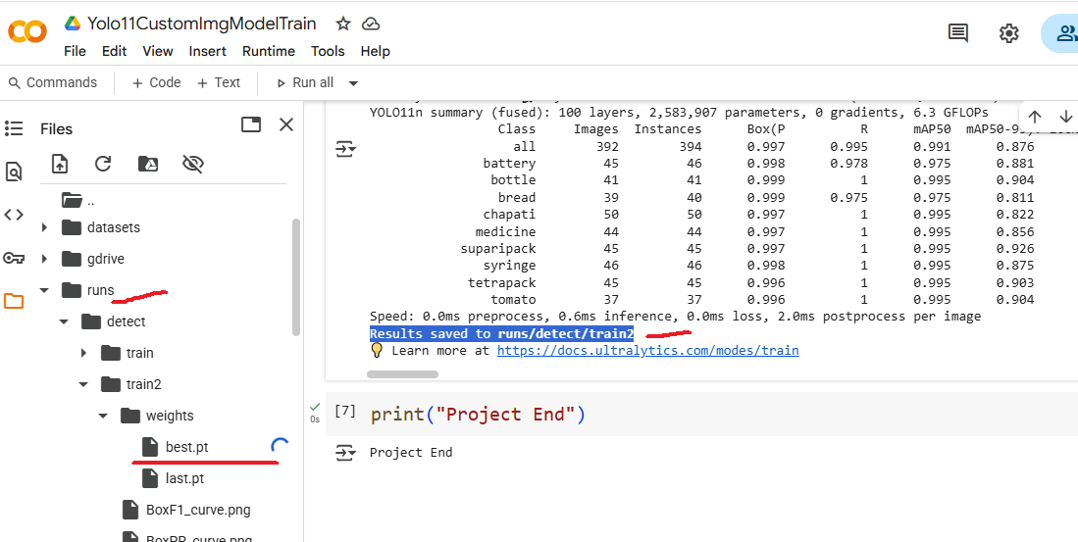

0: 192x256 (no detections), 98.3ms
Speed: 4.7ms preprocess, 98.3ms inference, 1.8ms postprocess per image at shape (1, 3, 192, 256)
ultralytics.engine.results.Boxes object with attributes:

cls: tensor([])
conf: tensor([])
data: tensor([], size=(0, 6))
id: None
is_track: False
orig_shape: (480, 640)
shape: torch.Size([0, 6])
xywh: tensor([], size=(0, 4))
xywhn: tensor([], size=(0, 4))
xyxy: tensor([], size=(0, 4))
xyxyn: tensor([], size=(0, 4))
[]

0: 192x256 1 Wooden_Block, 75.1ms
Speed: 1.6ms preprocess, 75.1ms inference, 2.3ms postprocess per image at shape (1, 3, 192, 256)
ultralytics.engine.results.Boxes object with attributes:

cls: tensor([6.])
conf: tensor([0.1720])
data: tensor([[3.8111e+02, 1.5950e+02, 5.4898e+02, 3.1476e+02, 1.7195e-01, 6.0000e+00]])
id: None
is_track: False
orig_shape: (480, 640)
shape: torch.Size([1, 6])
xywh: tensor([[465.0440, 237.1324, 167.8724, 155.2561]])
xywhn: tensor([[0.7266, 0.4940, 0.2623, 0.3235]])
xyxy: tensor([[381.1078, 159.5044, 548.9802, 314.7604]])
xyxyn: tensor([[0.5955, 0.3323, 0.8578, 0.6558]])
None

0: 192x256 2 Plastic_Fishs, 93.0ms
Speed: 4.8ms preprocess, 93.0ms inference, 1.7ms postprocess per image at shape (1, 3, 192, 256)
ultralytics.engine.results.Boxes object with attributes:

cls: tensor([3., 3.])
conf: tensor([0.4314, 0.2674])
data: tensor([[3.6074e+01, 2.9449e+02, 1.7398e+02, 3.8685e+02, 1.0000e+00, 4.3138e-01, 3.0000e+00],
[9.6029e+01, 1.0160e+02, 2.2549e+02, 2.1414e+02, 1.1000e+01, 2.6736e-01, 3.0000e+00]])
id: tensor([ 1., 11.])
is_track: True
orig_shape: (480, 640)
shape: torch.Size([2, 7])
xywh: tensor([[105.0276, 340.6676, 137.9066, 92.3618],
[160.7607, 157.8671, 129.4630, 112.5407]])
xywhn: tensor([[0.1641, 0.7097, 0.2155, 0.1924],
[0.2512, 0.3289, 0.2023, 0.2345]])
xyxy: tensor([[ 36.0743, 294.4867, 173.9810, 386.8485],
[ 96.0292, 101.5968, 225.4922, 214.1375]])
xyxyn: tensor([[0.0564, 0.6135, 0.2718, 0.8059],
[0.1500, 0.2117, 0.3523, 0.4461]])

